###### (a,b)

|  |  |  |  |  |
| --- | --- | --- | --- | --- |
|  | NT | NSIM | Call | Put |
| Batch 1 | 100 | 10, 000 | 2.10932 | 5.90807 |
| 100 | 100, 000 | 2.13295 | 5.87321 |
| 500 | 10, 000 | 2.12329 | 5.93754 |
| 500 | 100, 000 | 2.14885 | 5.83729 |
| Batch 2 | 100 | 10, 000 | 7.88566 | 8.02358 |
| 100 | 100, 000 | 7.96187 | 8.01715 |
| 500 | 10, 000 | 7.90847 | 8.13933 |
| 500 | 100, 000 | 8.0094 | 7.95242 |

We will never obtain the exact same answer as the exact solution. The value we get from Monte Carlo follows a distribution with the exact answer as to its mean. Increasing NT and NSIM can reduce the variance of distribution and thus we can make the value of Monte Carlo as near to the exact solution as possible.

(c)

For the put option, in order to achieve 2 decimal, NT=950 and MSIM=1,000,000.

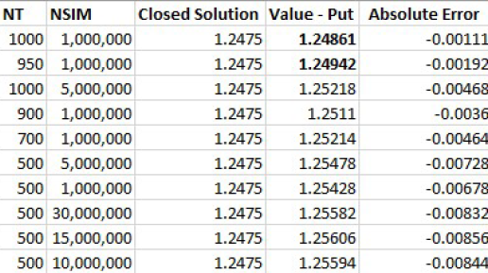

For the call option, it seems that it may require NSIM, NT to achieves that. I did not get the exact results due to the run-time limit. But a bigger NSIM and NT will solve the problem.

